CHAPTER 15
MECHANICAL WAVES
Discussion Questions

Q15.1 (a) Yes. The frequency depends on whatever is producing the waves. For example, in Fig.15.3 the frequency of oscillation of the block equals the frequency of the waves that it produces on the string. (b) Yes. The wave speed depends solely on the properties of the string, its tension and mass per unit length. So, the answer to (c) is that the two waves on the same string must have the same wave speed. But 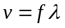, so if f is different and v is the same, must be different. (c) No. (d) Yes. The amplitude depends on whatever is producing the waves. (e) No. . v must be the same. If f is also the same, then can’t be different.

Q15.2 If the wave has length L and tension F, the speed of a wave pulse on the wire is 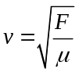. The time it takes a pulse to travel the length of the wire is 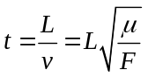. Ignoring a slight stretching of the wire when the tension is increased, L and are constant and 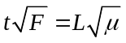 is constant. Therefore, 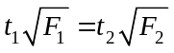 where 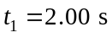, 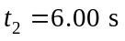 and 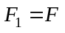. 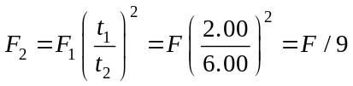. The tension must be decreased in order for the wave speed to decrease and for the pulse to take longer to travel the length of the wire.

Q15.3 There is kinetic energy of the moving string and the elastic potential energy of the string when it is displaced from equilibrium. The kinetic energy could be transferred to an object attached to the end of the string.

Q15.4 The energy in the wave decreases. The wave energy is transferred to the thermal energy in the string due to dissipative forces within the string.

Q15.5 The wave speed is independent of the amplitude of the wave. It depends only on the properties of the medium. Eq.(15.14) is an example of this.

Q15.6 The waves slow down as they approach the shore. This causes the water to pile up and produce crests.

Q15.7 The answer is yes to both questions. All that is required is to have a restoring force when a section of the string is displaced longitudinally or when a section of the rod is given a transverse displacement. To produce a longitudinal wave in a stretched string pull longitudinally at a point of the string and release it. The more elastic the string the easier this is to do. To produce transverse waves in a rod, clamp the rod at one end and tap in the transverse direction at some point on the rod. Transverse waves also can be easily set up in a rod clamped at some point by stroking the rod between your fingers.

Q15.8 The wave speed is 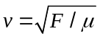. Each part of the string undergoes SHM with maximum speed given by 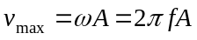. These two speeds are totally different. The wave speed is constant along the length of the string. At any instant the transverse speed of each point on the string varies along the length of the string and the transverse speed of any point on the string varies in time.
Q15.9 Eq.(15.14) says that waves travel faster on the thin strings, since they have smaller . 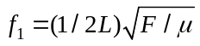, so the fundamental frequency 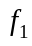 is higher for the thin strings.

Q15.10 As Eq.(15.21) shows, the power at a point on the string at a given time is given by the product of the transverse force component 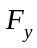 and the transverse velocity 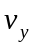 of this point on the string. The product of and always has the same sign, even though is negative as often as it is positive. Therefore, the power 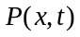 at a given location and time is proportional to 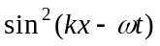 (Eq.(15.23)). This quantity is always positive and its average over one or more cycles is equal to , not zero.

Q15.11 ; the wave speed changes when changes. The frequency 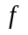 is the number of cycles per second and won’t change. 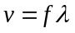 so when changes the wavelength must also change.

Q15.12 The tension is zero at the bottom of the rope and at the top of the rope the tension is equal to the weight of the rope. so the wave speed increases as the pulse travels up the rope (Example 15.3).

Q15.13 The wave disturbance travels along the length of the string. When one section of the string is displaced it exerts a force on the adjacent section and this allows for one section to do work on the adjacent section and to thereby transfer energy to it.

Q15.14 The node never has any displacement. No displacement means no work is done on it by the adjacent sections of the string.

Q15.15 No, a standing wave is not produced if the two waves don’t have the same amplitude. Let one wave have amplitude and the other have amplitude 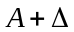. The wave with amplitude can be written as the sum of two waves, one with amplitude and the other with amplitude . The part with amplitude combines with the other wave to produce a standing wave but the part with amplitude remains a traveling wave. No, if the two waves have different frequencies they don’t combine to form a standing wave. Points at which there is destructive interference at a given time no longer have destructive interference at a slightly later time. Superposition of such waves form beats (Section 16.7) rather than standing waves.
Q15.16 The pitch increases as the rubber band is stretched. As the rubber band is stretched, 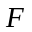 increases and decreases, so Eq.(15.35) says increases.
Q15.17 According to Eq.(15.35), to double the frequency the tension in the string must be increased by a factor of four. Therefore, to raise the pitch of the string one octave the tension in the string must be increased by a factor of four. To raise the pitch two octaves the tension must be increased a factor of sixteen. If the tension exceeds the breaking strength of the string, the string will break.

Q15.18 The finger on the middle of the string produces a node there, so the string vibrates in its first overtone. The frequency of the first overtone is twice the fundamental frequency.

Q15.19 The wall prevents longitudinal motion but offers no impediment to transverse motion.

Q15.20 According to Eq.(15.35), all else being equal a longer string has a lower fundamental frequency.

Q15.21 They mark places where the string can be held down to produce fundamental standing waves of different frequencies. The shorter the vibrating portion of a string, the higher the frequency of its fundamental.

